iCoot System
SR | USER Requirements | GPT Results | VeriGen Results
 | The Customer browses the index. | 1 The system shall provide the Customer with the ability to browse the index. | 1. The system shall provide customer with the ability to browse the index.
 | He selects an index heading. | 2 The system shall provide the Customer with the ability to select an index heading from the index. | 2. The system shall be able to selects index heading.
 | The Customer selects to view Car-Models for the selected index heading. | 3 The system shall provide the Customer with the ability to view Car-Models for a selected index heading. | 3. The system shall provide customer with the ability to select to view carmodels for the selected index heading.
 | To view the results ViewResults usecase is carried out. | MISSING | 4. The system shall be able to view usecase results viewresults carried.
 | The system presents the Customer with a summary of each retrieved CarModel, including model number with price. | 4 The system shall be able to retrieve CarModels corresponding to the selected index heading.  5 The system shall present the Customer with a summary of each retrieved CarModel, including model number and price. | 5. The system shall be able to present the customer with a summary of each retrieved carmodel , including model number with price.
 | The customer views the cars. | 6 The system shall provide the Customer with the ability to view the list of cars retrieved. | 6. The system shall provide customer with the ability to view the cars.
 | To view the car model details, ViewCarModelDetails use case is carried out. | MISSING | 7. The system shall be able to view car model details , viewcarmodeldetails use case carried.
 | The customer should be logged into iCoot system. | 10 The system shall require the Customer to be logged into the iCoot system to view CarModel details. | 8. The system shall provide customer with the ability to logged in.
 | The Customer selects one of the matching CarModels. | 7 The system shall provide the Customer with the ability to select a CarModel from the list of matching CarModels. | 9. The system shall provide customer with the ability to select one of the matching carmodels.
 | The Customer requests details of the selected CarModel. | 8 The system shall provide the Customer with the ability to request details of a selected CarModel. | 10. The system shall provide customer with the ability to request details of the selected carmodel.
 | The system displays details for the selected car model including makes, engine size, price, description, advert, poster. | 9 The system shall display details for the selected CarModel, including make, engine size, price, description, advert, and poster. | 11. The system shall be able to display details for the selected car model including makes , engine size , price , description , advert , poster.
 | If Customer wants to make a reservation then MakeReservation use case is carried out. | 13 The system shall provide the Customer with the ability to make a reservation for a CarModel. | 12. If customer wants to make a reservation then the system shall be able to carry makereservation use case out.
 | The customer selects the required categories and he selects the required Makes. | 14 The system shall provide the Customer with the ability to select required categories for the reservation. | - The system shall provide customer with the ability to select the required categories.  14. The system shall be able to selects makes.
 | The Customer also selects the required engine sizes and he initiates the search. | 16 The system shall provide the Customer with the ability to select required engine sizes for the reservation.  17 The system shall provide the Customer with the ability to initiate a search for CarModels based on selected categories, makes, and engine sizes. | 15. The system shall provide customer with the ability to also select the required engine sizes and customer initiates the search.
 | If Customer specifies no categories, makes or engine sizes then the system ask the Customer to enter either required categories. | 18 If the Customer specifies no categories, makes, or engine sizes, then the system shall prompt the Customer to enter at least one required category. | 16. If customer specifies no categories, makes or engine sizes then the system shall be able to specify ask customer to enter either required categories.
 | Member has already obtained a password from their local Store. | MISSING | 17. The system shall provide member with the ability to already obtain a password from their local store.
 | The Member enters the membership number. | 19 The system shall provide the Member with the ability to enter a membership number. | 18. The system shall provide member with the ability to enter the membership number.
 | The Member enters the password. | 20 The system shall provide the Member with the ability to enter a password. | 19. The system shall provide member with the ability to enter the password.
 | The Member elects to log on. | 21 The system shall provide the Member with the ability to elect to log on. | 20. The system shall provide member with the ability to elect to log on.
 | The system displays the Member's Window. | 22 The system shall display the Member's Window upon successful logon. | 21. The system shall be able to display the members window.
 | If the Member elects View Member Details then View_MemberDetails usecase is carried out. | 24 If the Member elects to view Member Details, then the system shall carry out the View_MemberDetails use case. | 22. If the member elects view member details then the system shall be able to viewmemberdetail usecase carried out.
 | The system again displays the Member's Window. | 25 The system shall display the Member's Window after viewing Member Details. | 23. The system shall be able to again display the members window.
 | If the Member elects View Rentals then ViewRentals usecase is visited. | 27 If the Member elects to view Rentals, then the system shall carry out the ViewRentals use case. | 24. If the member elects view rentals then the system shall be able to visit viewrentals usecase.
 | The system displays a message on Member's Window. | 28 The system shall display a message on the Member's Window after viewing Rentals. | 25. The system shall be able to display a message on members window.
 | If the member elects Log Off then LogOff use case is used. | 30 If the Member elects to log off, then the system shall carry out the LogOff use case. | 26. If the member elects log off then the system shall be able to log logoff use case used.
 | The customer should be logged into the system. | 31 The system shall require the Customer to be logged into the system to access member functions. | 27. The system shall provide customer with the ability to logged in.
 | If the customer is not logged in then the system asks him to log in, LogOn usecase is carried out. | 32. If the Customer is not logged in, then the system shall prompt the Customer to log in before accessing member functions. | 28. If the customer is not logged in then the system shall be able to log asks him to log in , logon usecase carried out.
 | For security reasons, the system must display only the last four digits of the Member’s CreditCard number. | 33 For security reasons, the system shall display only the last four digits of the Member’s CreditCard number in all views. | 29. The system shall be able to display only the last four digits of the members creditcard number.
 | The system presents the Member with membership details including name, address, status, amount owing, CreditCard details. | 34 The system shall present the Member with membership details including name, address, status, amount owing, and CreditCard details. | 30. The system shall be able to present the member with membership details including name , address , status , amount owing , creditcard details.
 | The system informs the Member to verify the details. | 35 The system shall inform the Member to verify the displayed membership details. | 31. The system shall be able to inform the member to verify the details.
 | If there are corrections in the details then system asks member to contact local Store. | 36 If there are corrections needed in the membership details, then the system shall instruct the Member to contact the local Store. | 32. If there are corrections in the details then the system shall be able to ask member to contact local store.
 | The system verifies the details entered by the member. | 37 The system shall verify the details entered by the Member during membership detail updates. | 33. The system shall be able to verify the details entered by the member.
 | The system shows the details. | 38 The system shall display the verified details to the Member. | 34. The system shall be able to show the details.
 | The member is logged on in advance. | 39 The system shall require the Member to be logged on before reserving a CarModel. | 35. The system shall provide member with the ability to logged in.
 | The Member elects to reserve the CarModel for the details on display. | 40 The system shall provide the Member with the ability to reserve the CarModel currently displayed. | 36. The system shall provide member with the ability to elect to reserve the carmodel for the details on display.
 | The Assistant asks the Member for confirmation. | 41 The system shall prompt the Member for confirmation before completing a reservation. | 37. The system shall be able to asks assistant member confirmation.
 | The system issues a warning that failure to collect a reserved CarModel will result in a fine. | 42 The system shall issue a warning to the Member that failure to collect a reserved CarModel will result in a fine. | 38. The system shall be able to issue a warning that failure to collect a reserved carmodel result in a fine.
 | If Member declines Reservation conditions then the system again asks the Member for confirmation. | 43 If the Member declines the reservation conditions, then the system shall prompt the Member for confirmation again. | 39. If member declines reservation conditions then the system shall be able to ask again member for confirmation.
 | The member confirms the Reservation. | 44 The system shall complete the reservation only if the Member confirms the reservation. | 40. The system shall provide member with the ability to confirm the reservation.
 | The system shows the member the Reservation number. | 45 The system shall display the Reservation number to the Member after successful reservation. | 41. The system shall be able to show the member the reservation number.
 | The system indicates the Member that an Assistant will be in touch when the requested Car is available. | 46 The system shall indicate to the Member that an Assistant will be in touch when the requested Car is available. | 42. The system shall be able to indicate the member that an assistant in touch when the requested car available.
 | When an Assistant logs on to iCoot then the system gives the Assistant a list of Reservations that require action. | 47 When an Assistant logs on to iCoot, the system shall present the Assistant with a list of Reservations that require action. | MISSIG
 | The Assistant takes necessary action to progress Reservations. | 48 The system shall provide the Assistant with the ability to take necessary actions to progress Reservations. | 43. The system shall be able to takes necessary assistant action progress reservations.
 | The Member elects to view the Rentals. | 49 The system shall provide the Member with the ability to view Rentals. | 44. The system shall provide member with the ability to elect to view the rentals.
 | The system presents the Member with summary of each Car the Member currently have out for rent including number plate ,due date. | 50 The system shall present the Member with a summary of each Car currently out for rent, including number plate and due date. | 45. The system shall be able to present the member with summary of each car the currently have out for rent including number plate , due date.
 | The system presents Member with summaries of Cars currently rented. | 51 The system shall present the Member with summaries of Cars currently rented. | 46. The system shall be able to present member with summaries of cars currently rented.
 | If no information is shown then the system asks member to select a valid options. | 52 If no rental information is shown, then the system shall prompt the Member to select a valid option. | 47. If no information is shown then the system shall be able to ask member to select a valid options.
 | The member should be logged into iCoot system. | 53 The system shall require the Member to be logged into the iCoot system to change the password. | 48. The system shall provide member with the ability to logged in.
 | The system asks him to enter the old password. | 54 The system shall prompt the Member to enter the old password when changing the password. | 49. The system shall be able to ask him to enter the old password.
 | Member enters the old password. | MISSING | 50. The system shall provide member with the ability to enter the old password.
 | The system asks member to enter a new password. | 55 The system shall provide the Member with the ability to enter a new password. | 51. The system shall be able to ask member to enter a new password.
 | The Member enters a new password. | MISSING | 52. The system shall provide member with the ability to enter a new password.
 | The Member enters the new password again. | 56 The system shall prompt the Member to enter the new password again for confirmation. | 53. The system shall provide member with the ability to enter the new password again.
 | The Member initiates the change. | 57 The system shall provide the Member with the ability to initiate the password change. | 54. The system shall provide member with the ability to initiate the change.
 | The system asks the Member for confirmation. | 58 The system shall prompt the Member for confirmation before changing the password. | 55. The system shall be able to ask the member for confirmation.
 | The member confirms it. | MISSING | 56. The system shall provide member with the ability to confirm it.
 | The system validates the password. | 59 The system shall validate the new password according to system rules. | 57. The system shall be able to validate the password.
 | The system displays a warning to the Member “Please memorize your password”. | 60 The system shall display a warning to the Member to memorize the new password after a successful password change. | 58. The system shall be able to display a warning to the member please memorize your password.
 | The member should be logged into iCoot system. | 61 The system shall require the Member to be logged into the iCoot system to view reservations. | 59. The system shall provide member with the ability to logged in.
 | If the customer is not logged in then the system asks him to log in, LogOn usecase is carried out. | 62 If the Member is not logged in, then the system shall prompt the Member to log in before viewing reservations. | 60. If the customer is not logged in then the system shall be able to log asks him to log in , logon usecase carried out.
 | He should have a reservation to view the reservations. | 63 The system shall require the Member to have at least one reservation to view reservations. | 61. The system shall provide reservation with the ability to viewThe system shall be able to show a list of reservation made by the member.
 | The system shows a list of reservation made by the member. | 64 The system shall display a list of reservations made by the Member. | MISSING
 | The system displays the validated summaries of member’s reservations such as date, time, car models etc. | 65 The system shall display validated summaries of the Member’s reservations, including date, time, and car models. | 62. The system shall be able to display the validated summaries of members reservations such as date , time , car models etc.
 | The Member should be logged into iCoot system and should already have a Reservation. | 66 The system shall require the Member to be logged into the iCoot system and to have an existing reservation to cancel a reservation. | 63. The system shall provide member with the ability to logged in.
 | The Member selects to cancel the Reservation. | 67 The system shall provide the Member with the ability to select a reservation to cancel. | 64. Icoot haveThe system shall provide member with the ability to select to cancel the reservation.
 | The Assistant asks the Member for confirmation. | 68 The system shall prompt the Member for confirmation before cancelling a reservation. | 65. The system shall be able to asks assistant member confirmation.
 | Member confirms to cancel the Reservation. | MISSING | 66. The system shall provide member with the ability to confirm to cancel the reservation.
 | If Member doesn’t confirm a cancellation then that reservation is not cancelled by the system. | 69 If the Member does not confirm the cancellation, then the system shall not cancel the reservation. | 67. If member doesnt confirm a cancellation then the system shall be able to confirm that reservation not cancelled by.
 | The system marks the Reservation as Concluded. | 70 If the Member confirms the cancellation, then the system shall mark the reservation as Concluded. | 68. The system shall be able to mark the reservation as concluded.
 | The system updates the Assistant’s terminals accordingly. | 71 If the reservation is cancelled, then the system shall update the Assistant’s terminals accordingly. | 69. The system shall be able to update the assistants terminals accordingly.
 | The member should be logged into iCoot system. | 72 The system shall require the Member to be logged into the iCoot system to log off. | 70. The system shall provide member with the ability to logged in.
 | If the customer is not logged in then the system asks him to log in, LogOn usecase is carried out. | 73 If the Member is not logged in, then the system shall prompt the Member to log in before logging off. | 71. If the customer is not logged in then the system shall be able to log asks him to log in , logon usecase carried out.
 | The member selects to log off the iCoot system. | 74 The system shall provide the Member with the ability to log off the iCoot system. | 72. The system shall provide member with the ability to select to log off the icoot system.
 | The system ends the current session. | 75 The system shall end the current session upon log off. | 73. The system shall be able to end the current session.
 | The system makes the Member functions unavailable to Member. | 76 The system shall make Member functions unavailable to the Member after log off. | 74. The system shall be able to make the member functions unavailable to member.
 | If the member does not interact with the system for ten minutes then the member is logged off automatically by the system. | 77 If the Member does not interact with the system for ten minutes, then the system shall automatically log off the Member. | 75. If the member does not interact with the system for ten minutes then the system shall be able to log member off automatically by.
 | The system validates the member’s log off. | 78 The system shall validate the Member’s log off process. | 76. The system shall be able to validate the members log off.
 | The system asks customer to look for the CarModels. | 79 The system shall prompt the Customer to look for CarModels. | 77. The system shall be able to ask customer to look for the carmodels.
 | The customer retrieves a subset of CarModels from the catalog. | 80 The system shall provide the Customer with the ability to retrieve a subset of CarModels from the catalog based on selected options. | 78. The system shall provide customer with the ability to retrieve a subset of carmodels from the catalog.
 | The system displays all the possible models on the options selected by the customer. | 81 The system shall display all possible CarModels matching the options selected by the Customer. | 79. The system shall be able to display all the possible models on the options selected by the customer.
 |  | 11 If the Customer is not logged in, then the system shall prompt the Customer to log in.
 |  | 12 If the Customer is not logged in, then the system shall carry out the LogOn use case.
 |  | 15 The system shall provide the Customer with the ability to select required Makes for the reservation.
 |  | 23 The system shall provide the Member with the ability to elect to view Member Details.
 |  | 26 The system shall provide the Member with the ability to elect to view Rentals.
 |  | 29 The system shall provide the Member with the ability to elect to log off.
 |  | 82. The system shall handle invalid or incomplete input data by displaying appropriate error messages to the user.
 |  | 83. The system shall provide feedback to users upon successful completion of each action.
 |  | 84. The system shall provide error notifications if any system process fails.
 |  | 85. The system shall log all user actions for audit and traceability.
 |  | 86. The system shall prevent unauthorized access to member-only functions.
 |  | 87. The system shall lock the account after a configurable number of failed login attempts.
 |  | 88. The system shall provide the ability for Members to recover their password through a secure process.
 |  | 89. The system shall ensure all user sessions are securely managed and terminated upon log off.
 |  | 90. The system shall validate all user inputs for format and completeness before processing actions.
 |  | 91. The system shall provide clear navigation options for all major use cases.
 |  | 92. The system shall display confirmation messages for all critical actions (e.g., reservation, cancellation, password change).
 |  | 93. The system shall maintain the integrity of reservation and rental data at all times.
 |  | 94. The system shall ensure that only authorized Assistants can access the list of Reservations requiring action.
 |  | 95. The system shall provide Assistants with the ability to update the status of Reservations.
 |  | 96. The system shall notify Members when their requested Car is available.
 |  | 97. The system shall provide Members with the ability to view historical reservations and rentals.
 |  | 98. The system shall provide Members with the ability to update their contact information.
 |  | 99. The system shall display help or guidance for each major function.
 |  | 100. The system shall provide a logout notification to the Member upon successful log off.

Class Diagram (GPT)

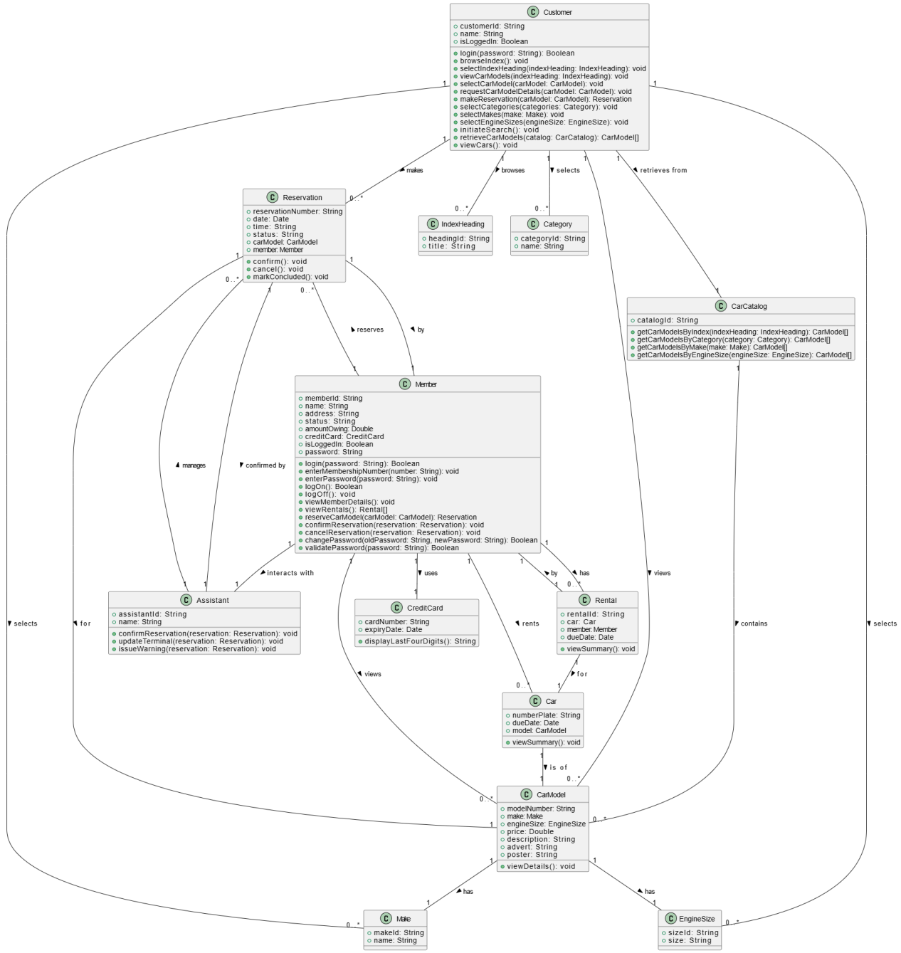

Class Diagram (VeriGen)

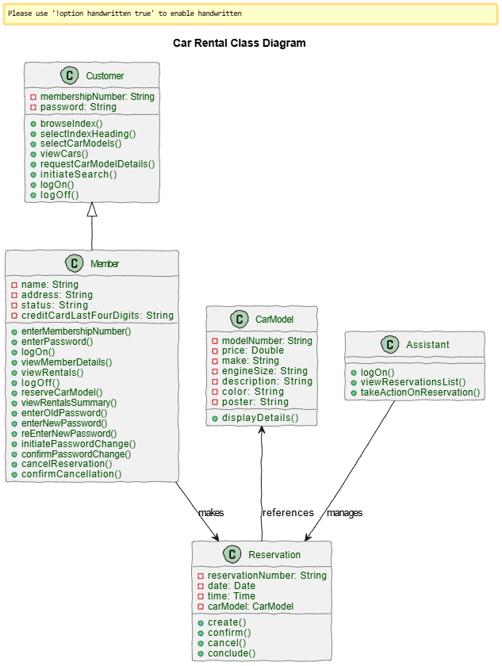

Sequence Diagram (VeriGen)
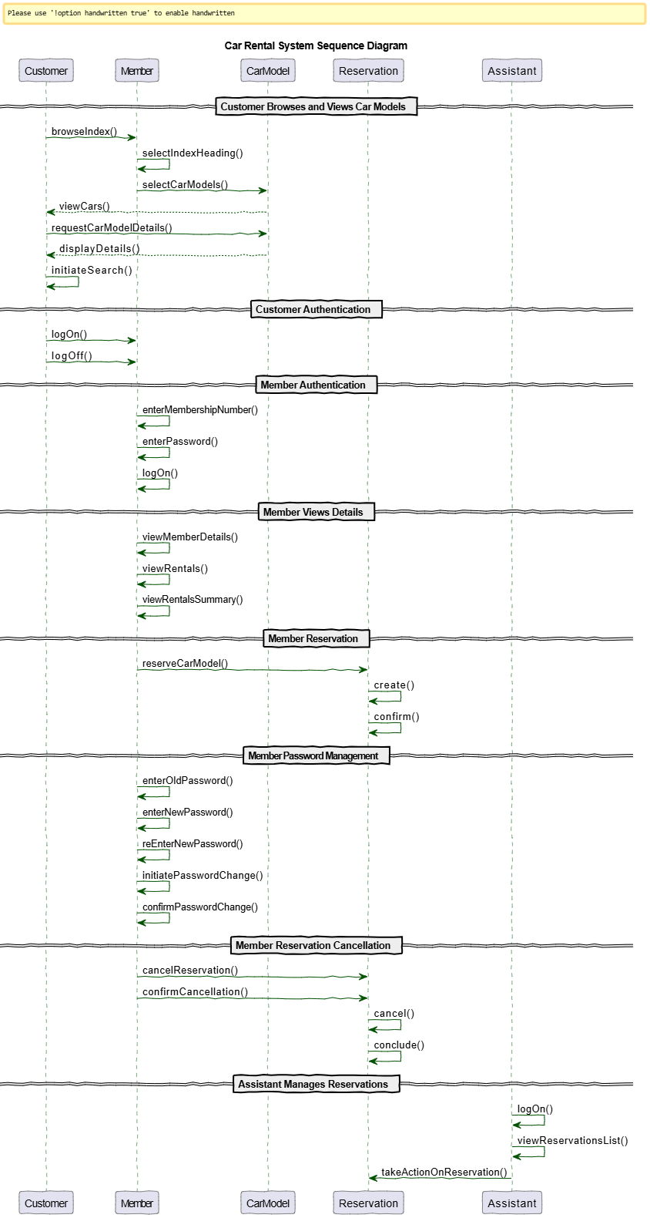

Sequence Diagram (GPT)

